NetBeans Platform Crash Course

By NetBeans User Group Serbia www.netbeans-serbia.org

In this tutorial we will explain some basics of creating NetBeans Platform application with NetBeans IDE 6.9.1

Overview
1. Creating NetBeans HelloWorld Application
  - Creating a NetBeans Platform suite
  - Creating a module and adding it to the Platform
  - Creating an action in the module
  - Running the NetBeans HelloWorld Application example
2. Expanding NetBeans application with another module
2.1 Creating and adding new module
  - Creating custom window – TopComponent
  - Creating an action in the module
  - Running multi-module Netbeans application
3. Adding wizard to existing module and using a singleton class
3.1 Creating a singleton class
3.2 Creating a custom wizard
3.3 Running mutli-module Netbeans application

Requirements
Java 1.6 or later
NetBeans 6.9.1 or later

Prerequisites
Basic Java and Swing programming
1. Creating NetBeans HelloWorld Application

We will start by creating a new NetBeans Platform application.
- In main menu go to File > New project. In the New project wizard in Categories section choose NetBeans modules.
- In Projects section choose NetBeans Platform Application project and click Next

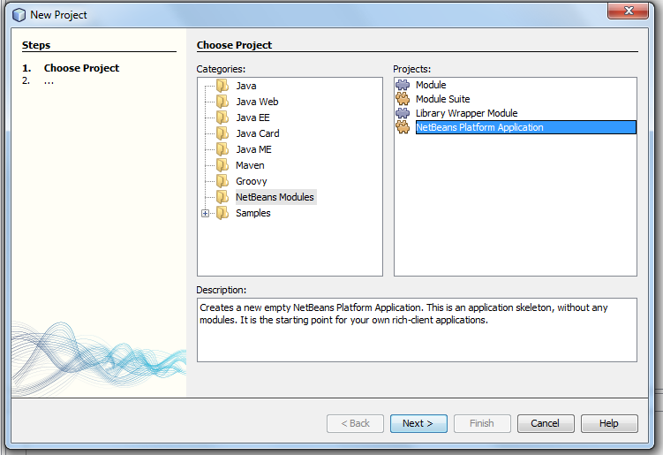

Set project name to MyNetBeansApplicationSuite for our module suite and click Finish button.

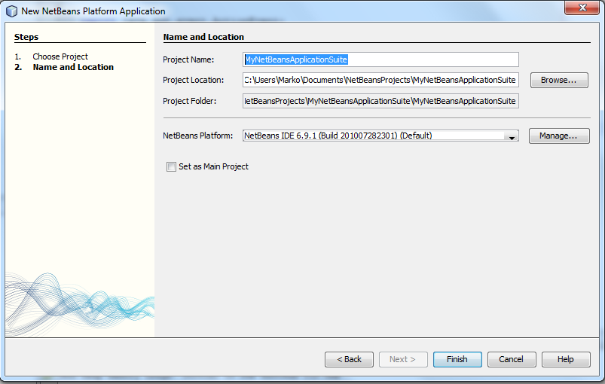

Now you should be able to see your application in in the Projects window

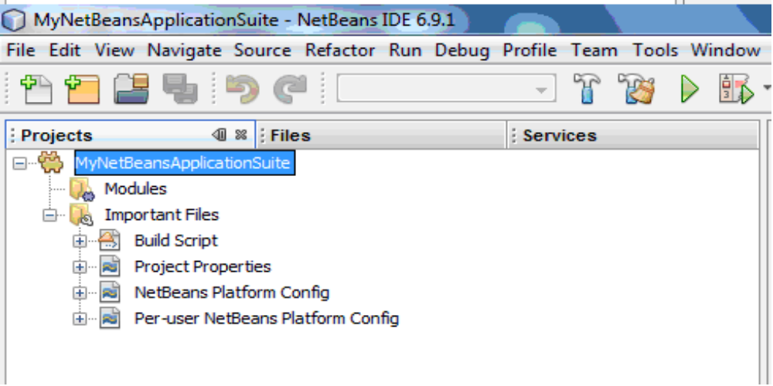
Next add a new module to the application. Right click on Modules Folder in our Module Suite and choose Add New

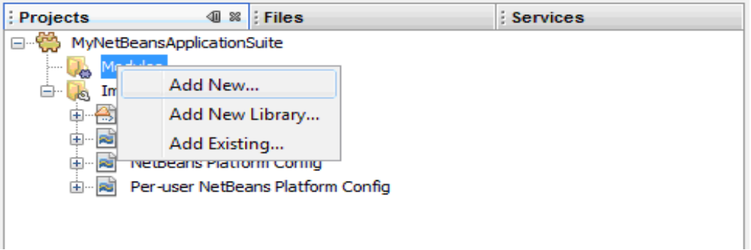

Set name of the module HelloWorld in the new Module Project. You can choose your project location. The default location is set in Module Suite that we are working on. Note that Module are Java Projects.

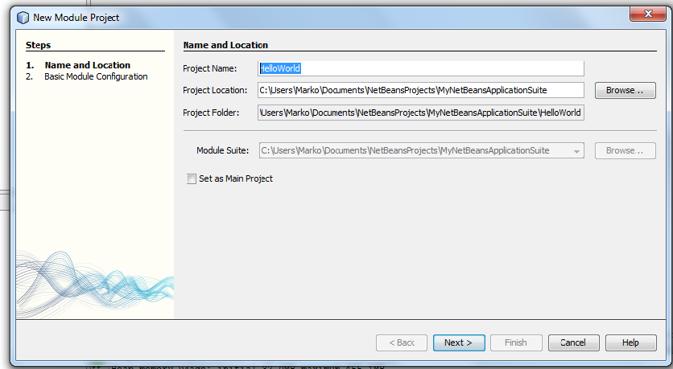
Set the Code Name Base field which represents the module base package and click Finish:

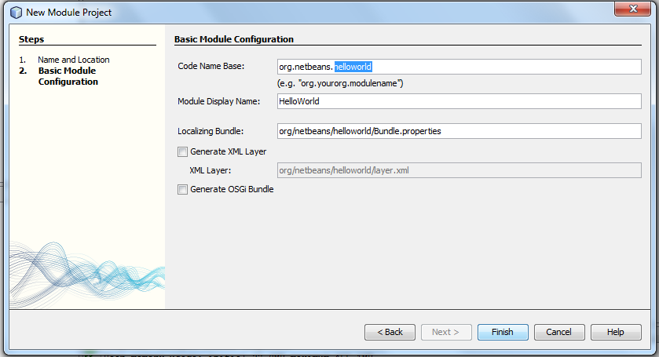

You should be able to see added Module in the Project window as below:

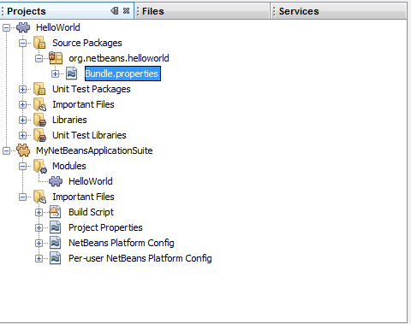
Now create Action class to make the application do something. Right click on the package org.netbeans.helloworld and choose New > Action

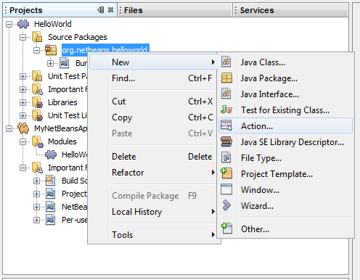

In the New Action wizard choose Always enabled:

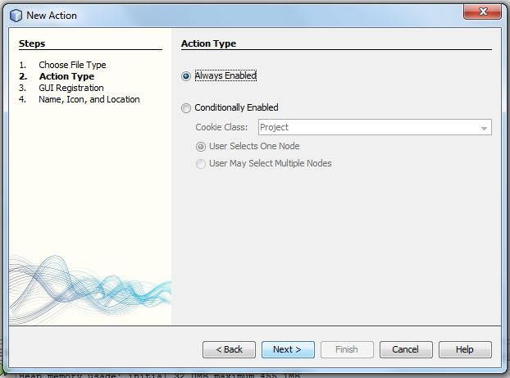

Always enabled means that the action will be always available. Conditionally enabled means that some conditions must be fulfilled for action to be enabled (otherwise it will be disabled).

In next step choose GUI Registration, where the Action will be available for user:

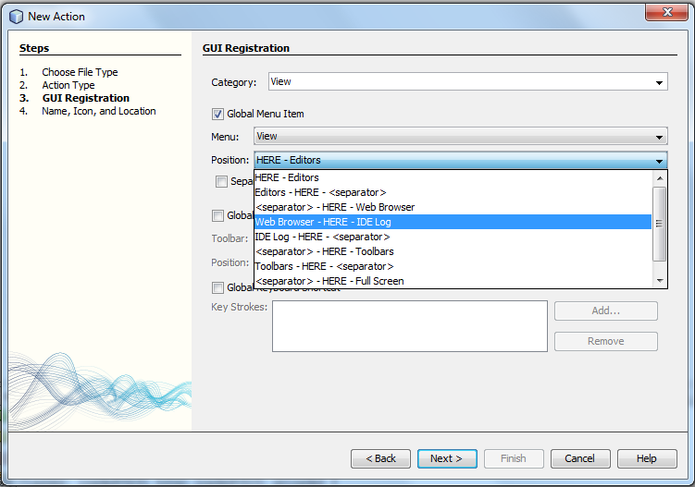
Now set class name to HelloAction and display name to Say Hello (that will be displayed in GUI where we registered in previous step ) and click Finish:

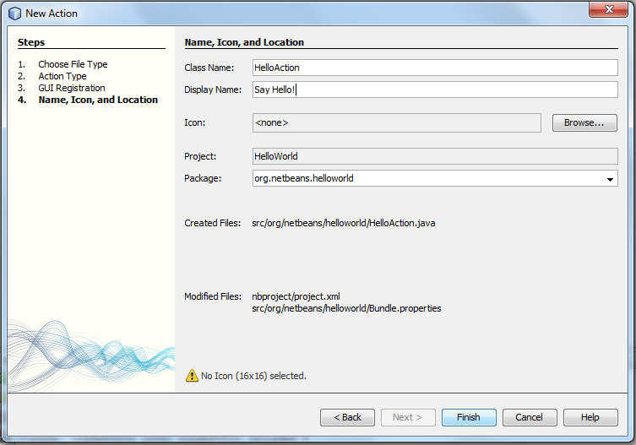

You should be able to see our Action class in project view as below:

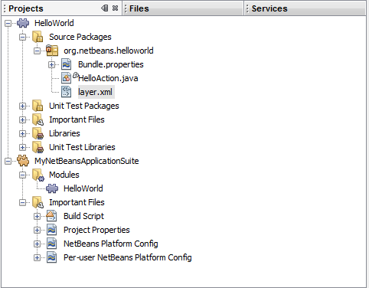

Note that the layer.xml file is created. This file all our Action and GUI setting in our module. In our case in the layer.xml contains registration of our Action and GUI position:

<?xml version="1.0" encoding="UTF-8"?>
<!DOCTYPE filesystem PUBLIC "-//NetBeans//DTD Filesystem 1.2//EN" "http://www.netbeans.org/dtds/filesystem-1_2.dtd">
<filesystem>
<folder name="Actions">
<folder name="View">
<file name="org-netbeans-helloworld-HelloAction.instance">
<attr name="delegate" newvalue="org.netbeans.helloworld.HelloAction"/>
<attr name="displayName" bundlevalue="org.netbeans.helloworld.Bundle#CTL_HelloAction"/>
<attr name="instanceCreate" methodvalue="org.openide.awt.Actions.alwaysEnabled"/>
<attr name="noIconInMenu" boolvalue="false"/>
</file>
</folder>
</folder>
<folder name="Menu">
<folder name="View">
<file name="org-netbeans-helloworld-HelloAction.shadow">
<attr name="originalFile" stringvalue="Actions/View/org-netbeans-helloworld-HelloAction.instance"/>
<attr name="position" intvalue="0"/>
</file>
</folder>
</folder>
</filesystem>

Now we will add some code to our HelloAction class. We will use already installed window component from NetBeans and that’s the Output window. To use this feature first we will add a dependency on I/O API that will give us the provider for Output window.
Right click Module > Properties > Libraries > Tab Module dependency and click Add dependency:

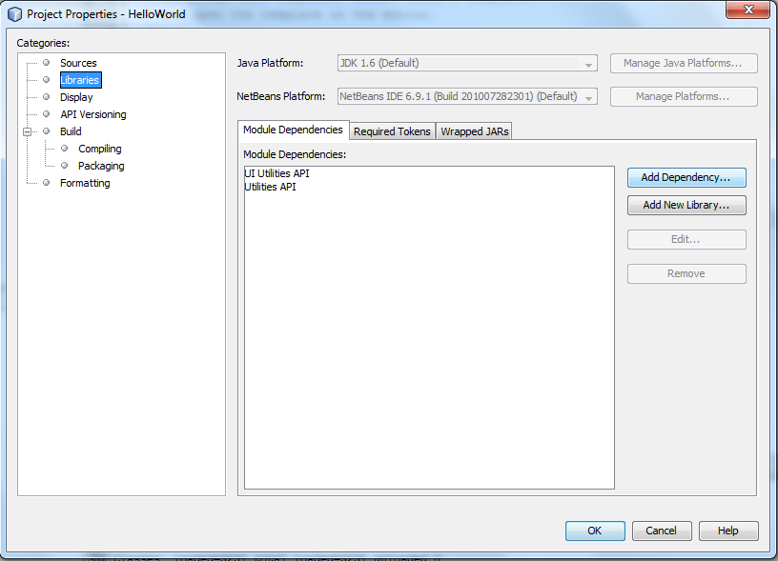

Select I/O APIs module and click OK:

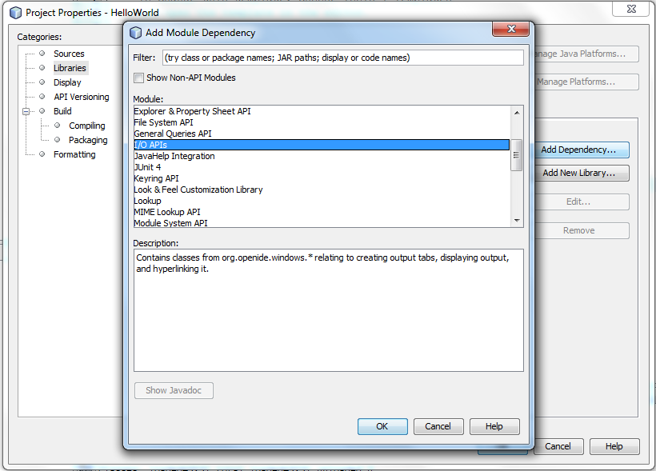
Now the required dependency is set for this module. Click OK to finish:

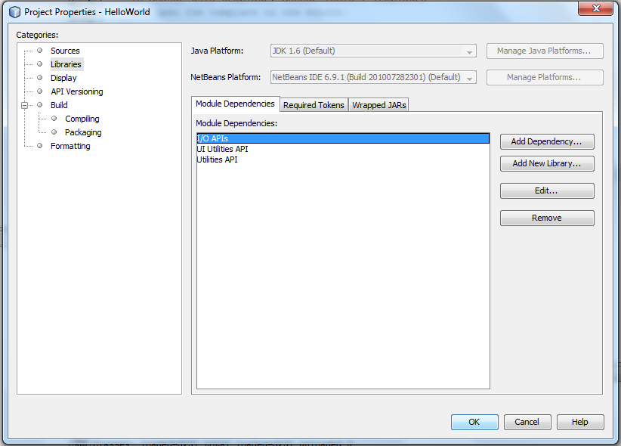

You can see all used libraries and modules in Project widow under the Libraries folder:

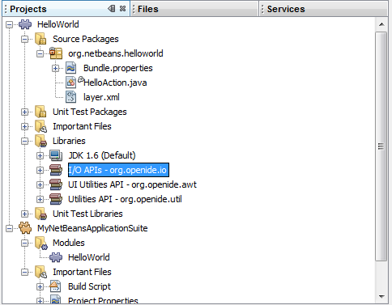

Now we will add code to our HelloAction as below. We’ll use the IOProvider to get the Output window and write in it:

package org.netbeans.helloworld;

import java.awt.event.ActionEvent;
import java.awt.event.ActionListener;
import java.io.PrintWriter;
import org.openide.windows.IOProvider;

public final class HelloAction implements ActionListener {

public void actionPerformed(ActionEvent e) {
PrintWriter out = IOProvider.getDefault().getIO("Hello", true).getOut();
out.println("Hello World!");
}
}

Now let’s try out our application. Right click on MyNetBeansApplicationSuite and choose Run:

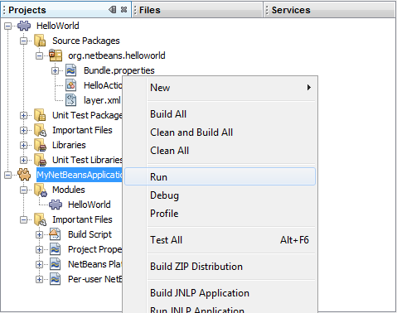

When starting NetBeans Platform based application the startup splash screen will pop up as below:

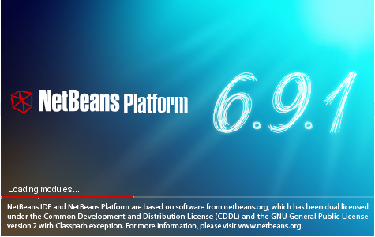

Note that it can be easily customized with your own splash screen.
When started, the application will appear like this:

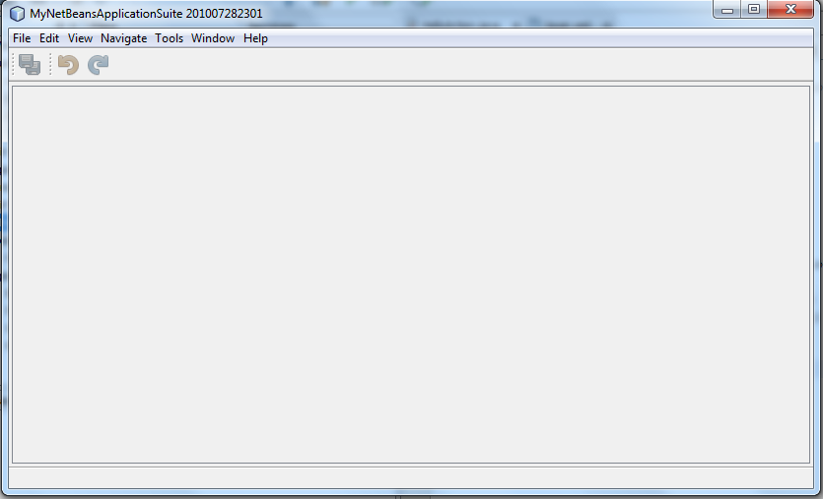

Lets turn on Output window. In main menu click Window > Output > Output, or simply press Ctrl+4:

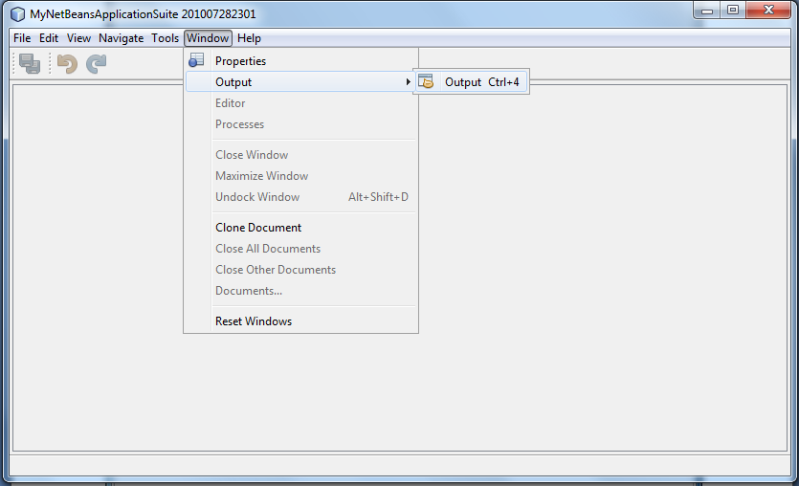

Output window will appear in its default location:
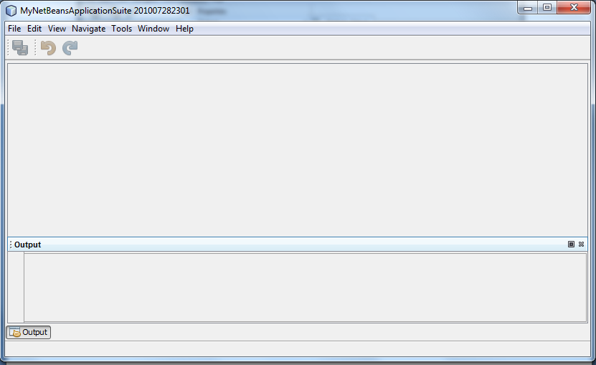

Later in this tutorial we will learn how to set location and other properties for our custom windows.
Let’s try our HelloAction. In main menu click View > Say Hello (note that this is the GUI location of action that we provided in GUI Registration in New Action Wizard):

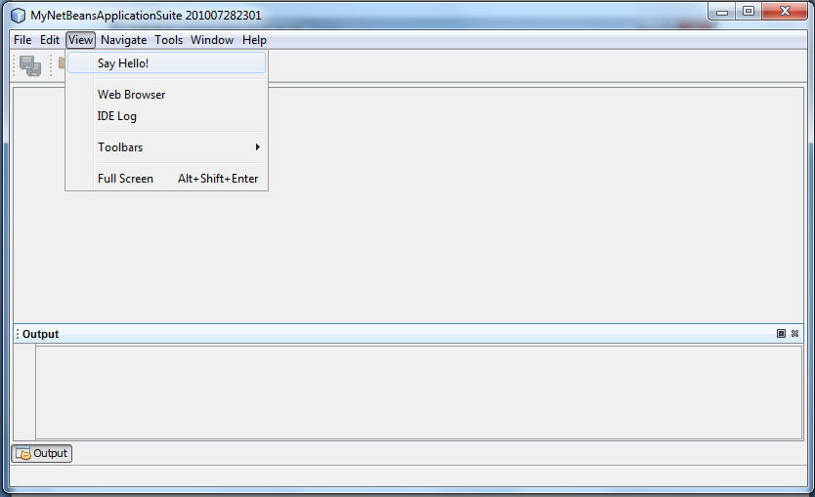

The result of HelloAction is shown below:

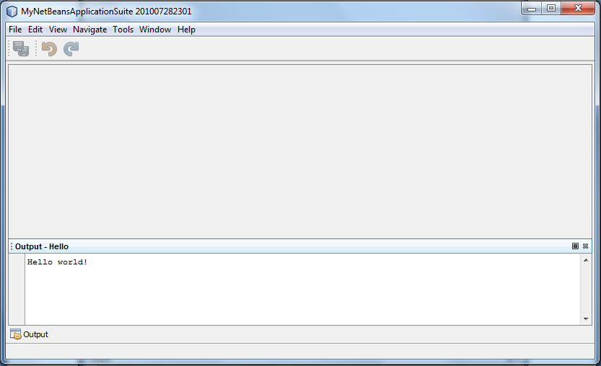
HelloAction used the IOProvider to get Output window and write ‘Hello World!’. It also labeled the Output window with ‘Hello’. This is useful when you want to specify what is the Output about (for example when you run application in Netbeans, the output window will start to log event of starting the application with label ‘Run’ ).

2. Expanding NetBeans application with another module

Now we will create a new module and add it to our application. This module will allow us to create the CD database. Right click on Modules Folder in our Module Suite and choose Add New:

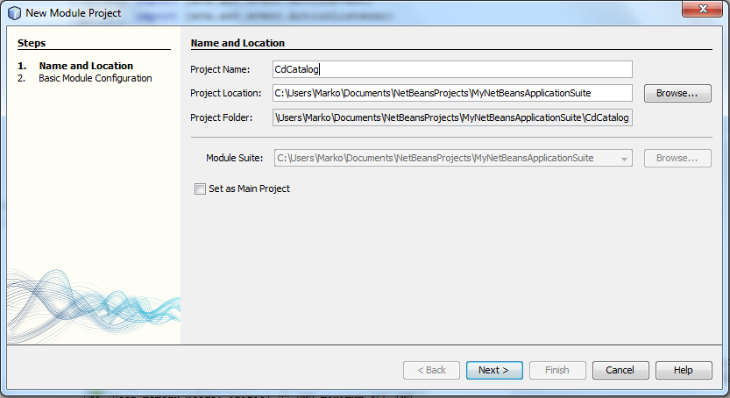

Set Code Base Name org.netbeans.cdcatalog and this time check Generate XML Layer:

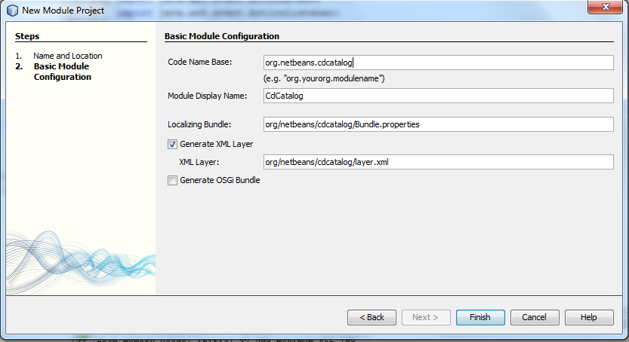
You should be able to see created module in Projects window:

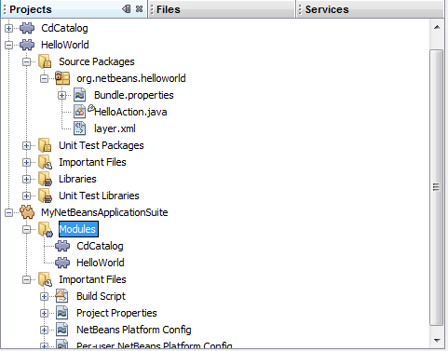

Now we will create a simple java class that will represent our domain object (CD).
Right click on cdcatalog package, select New > Java class and enter CD for the class name. Edit CD class as following:

package org.netbeans.cdcatalog;

public class CD {

String title;
String artist;

public CD() {
}

public CD(String title, String artist) {
this.title = title;
this.artist = artist;
}

public String getArtist() {
return artist;
}

public void setArtist(String artist) {
this.artist = artist;
}

public String getTitle() {
return title;
}

public void setTitle(String title) {
this.title = title;
}

@Override
public String toString() {
return "CD{" + "title=" + title + "artist=" + artist + '}';
}
}

Now let’s create our custom window to add some CDs.
2. Right click on package in CdCatalog module and select New > Window. This will start the New Window Wizard. In Basic Settings panel we are setting our window properties. Set window position to editor, which means that our window will be located in the central position of NetBeans application (for example Java class editor in NetBeans IDE).
We can also set some other window features like ‘Open on Application Start’ etc.

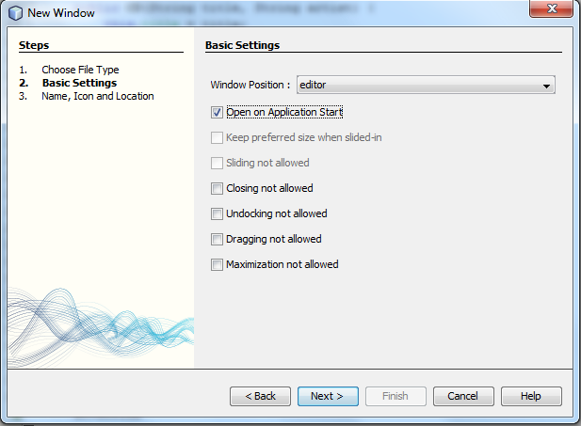
Then set prefix name CD which will append on TopComponent name for Java class and click Finish:

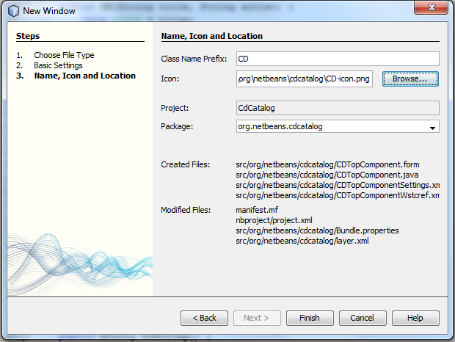

After this wizard you should be able to see CDTopCompnent.java class in Project window and two more files CDTopCompnentSettings.xml and CDTopCompnentWstcref.xml that store the settings for our window:

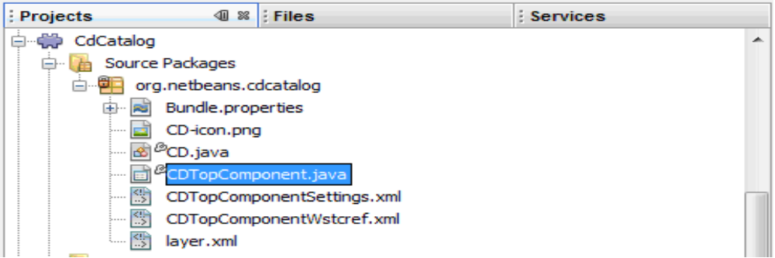
Add components to CDTopComponent via GUI Builder as below:

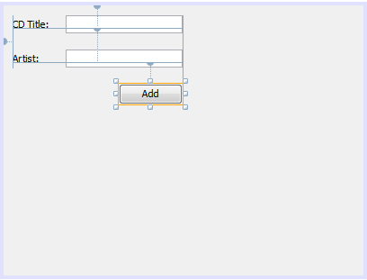
In Source view add cdDatabase attribute to CDTopComponent and generate getter for it:

private ArrayList<CD> cdDatabase = new ArrayList<CD>();

public ArrayList<CD> getCdDatabase() {
return cdDatabase;
}

Now add action for our Add button. Right click the button, and choose Action > actionPerformed

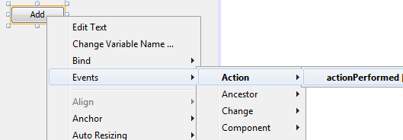

Edit java code in actionPreformed method as below:

private void addButtonActionPerformed(java.awt.event.ActionEvent evt) {
CD cd = new CD();
cd.setArtist(artistField.getText().trim());
cd.setTitle(titleField.getText().trim());
cdDatabase.add(cd);
titleField.setText("");
artistField.setText("");
}

This will create a new instance of CD, add it to the cdDatabase and clear the form.
3. Next, let’s create action to show all CDs from cdDatabase list. Right click on package in module and choose New > Action:

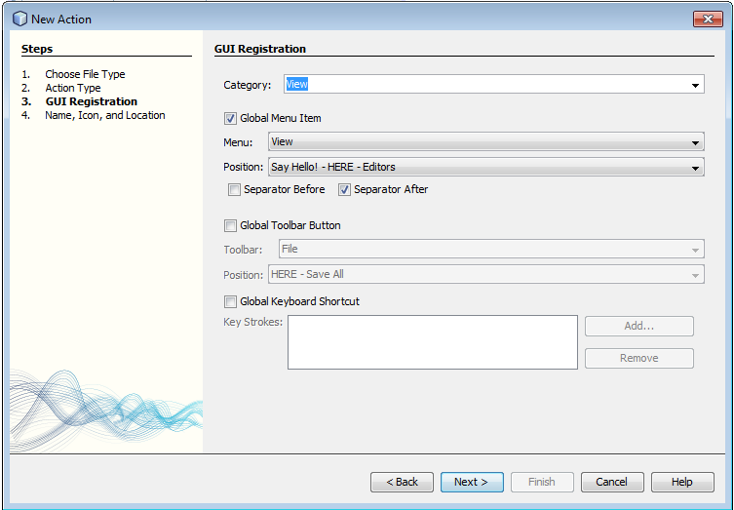

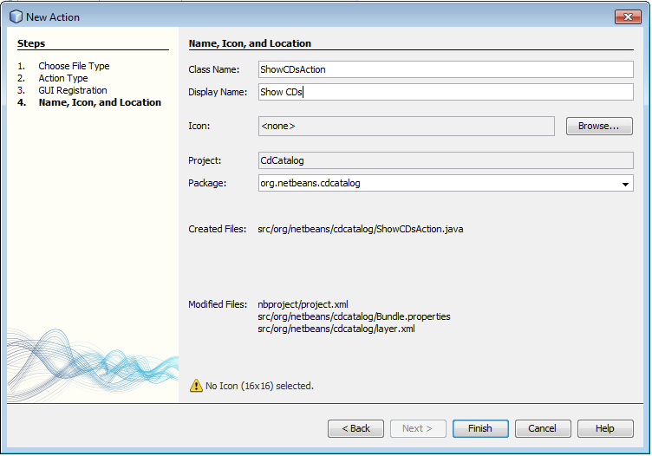

Edit java code for our ShowCDsAction as below:

package org.netbeans.cdcatalog;

import java.awt.event.ActionEvent;
import java.awt.event.ActionListener;
import java.io.PrintWriter;
import java.util.ArrayList;
import org.openide.windows.IOProvider;

public final class ShowCdsAction implements ActionListener {

@Override
public void actionPerformed(ActionEvent e) {
ArrayList<CD> cdDatabase = CDTopComponent.getDefault().getCdDatabase();
// or use another way for getting window through WindowManager
//CDTopComponent tc=WindowManager.getDefault().findTopComponent(“CdTopComponent”);

PrintWriter output = IOProvider.getDefault().getIO("CDs", false).getOut();
for(CD cd : cdDatabase) {
output.println(cd);
}
}
}

This will show all the CDs from our cdDatabase from CDTopComponent in default Output window.

Now let’s run our application a test it.

4.Rigth click on the MyNetBeansApplicationSuite and click Run. Application now looks like this:

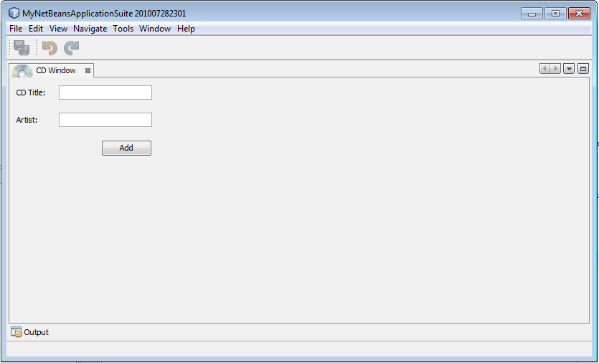

Our CDTopComponent window is showing at start up of application in the central/editor position.
Lets add a couple of CDs:

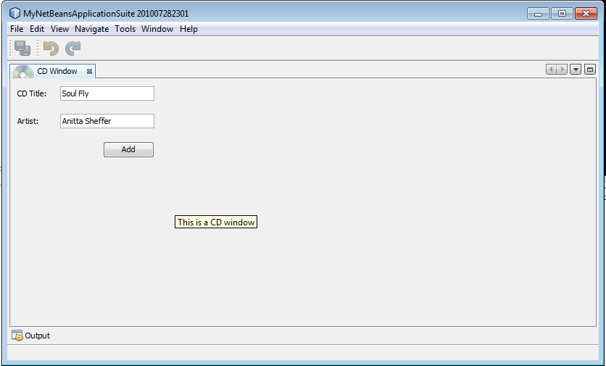

In the View menu click on Show CDs and it will start our action:

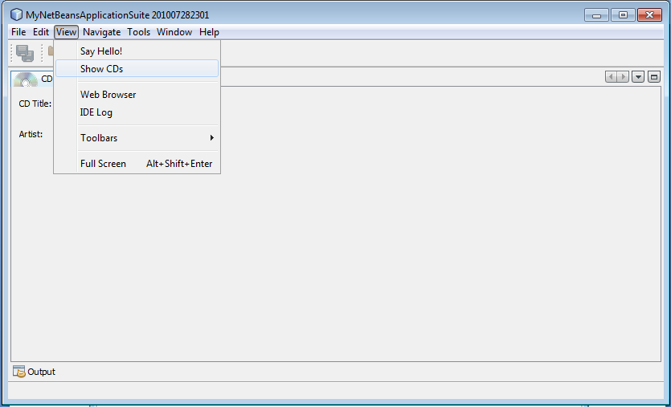
The result of our ShowCDsAction:

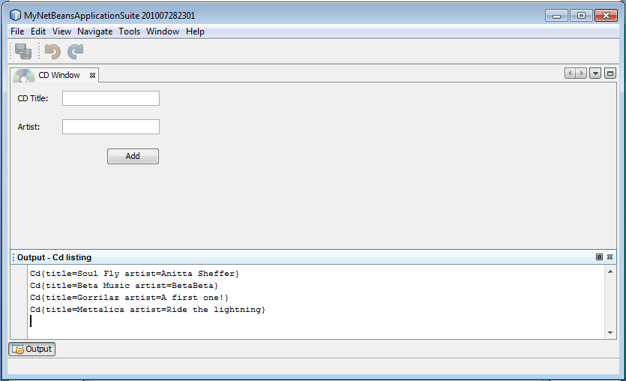

3. Adding wizard to existing module and using a singleton class

Now let’s add a Wizard in our application that will allow user to add CD in two steps, editing title, artist and song list of CD.

1.First we will create a Singleton CDDatabase class as below:

package org.netbeans.cdcatalog;

import java.util.ArrayList;

public class CDDatabase {

private static CDDatabase cdDatabase;
private ArrayList<CD> cds = new ArrayList<CD>();

private CDDatabase() {
}

public static CDDatabase getInstance() {
if (cdDatabase == null) {
cdDatabase = new CDDatabase();
}
return cdDatabase;
}

public void addCD(CD cd) {
cds.add(cd);
}

public ArrayList<CD> getCds() {
return cds;
}
}

The singleton means that this class will only have one instance in entire application. We want to have only one CD database to store CDs so we will use this pattern.
(For more info about software design patterns look at http://en.wikipedia.org/wiki/Design_pattern_(computer_science)
And for singleton pattern look at http://en.wikipedia.org/wiki/Singleton_pattern)

Next, edit our CD class as below to add songs:

package org.netbeans.cdcatalog;

public class CD {

String title;
String artist;
String songs;

public CD() {
}

public CD(String title, String artist) {
this.title = title;
this.artist = artist;
}

public CD(String title, String artist, String songs) {
this.title = title;
this.artist = artist;
this.songs = songs;
}

public String getArtist() {
return artist;
}

public void setArtist(String artist) {
this.artist = artist;
}

public String getTitle() {
return title;
}

public void setTitle(String title) {
this.title = title;
}

public String getSongs() {
return songs;
}

public void setSongs(String songs) {
this.songs = songs;
}

@Override
public String toString() {
return "CD{" + "title=" + title + "artist=" + artist +
"songs=" + songs + '}';
}

}

Now we will create wizard to add CDs into database. Right click on module package and choose
New > Wizard. It will start New Wizard wizard:

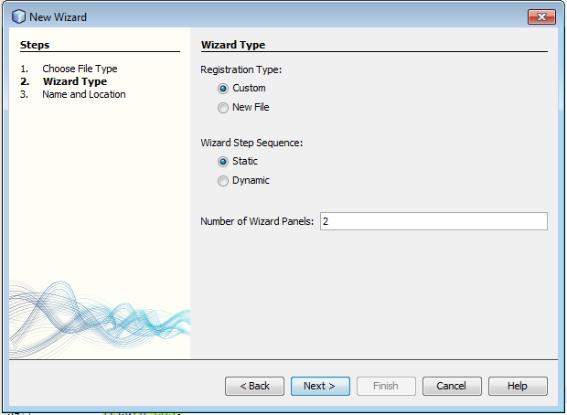

Registration Type is where it will our wizard be activated from. Step sequence defines the way of moving throw the steps of wizard. Let’s set number of panels (number of steps of wizard) 2. The first step is to add CD title and artist and the second to add song list.

Set name prefix NewCD nad click Finish:

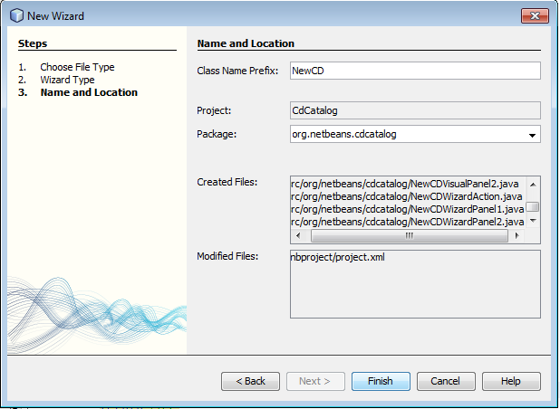

In project window you should see next:

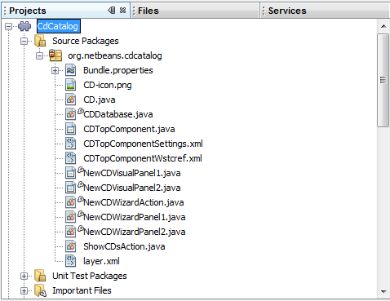

Visual panels represent what the user will see. Wizard panels provide some functions with Wizard descriptor such as storeSettings method that allows you to store and save some values from the visual panels. WizardAction defines what will happened after finishing the custom wizard steps. (For example after finishing Java class wizard the Java class is created and shown in project view)

Add fields to enter CD title an artist to NewCDVisualPanel1 and name them titleField and artistField:

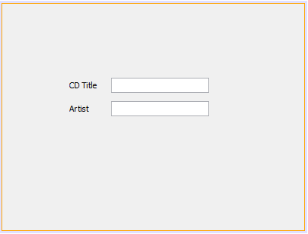
Add components to NewCDVisualPanel2:

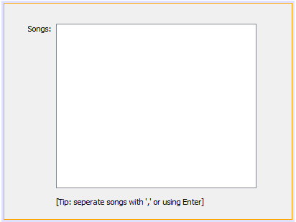

Edit source code in VisualPanel1 as below:

@Override
public String getName() {
return "Set CD Title and Artist";
}

public JTextField getArtistField() {
return artistField;
}

public JTextField getTitleField() {
return titleField;
}

Edit source code in VisualPanel2 as below:

@Override
public String getName() {
return "AAdd Songs to CD";
}

public JTextArea getSongsTextArea() {
return songsTextArea;
}

Edit source code in WizardPanel1 as below:

@Override
public void storeSettings(Object settings) {
NewCDVisualPanel1 panel = (NewCDVisualPanel1)getComponent();
((WizardDescriptor)settings).putProperty("title",
panel.getTitleField().getText().trim());
((WizardDescriptor)settings).putProperty("artist",
panel.getArtistField().getText().trim());
}

Edit source code in WizardPanel2 as below:

@Override
public void storeSettings(Object settings) {
NewCDVisualPanel2 panel = (NewCDVisualPanel2)getComponent();
((WizardDescriptor)settings).putProperty("songs",
panel.getSongsTextArea().getText().trim());
}

This code will save values from the fields via WizardDescriptor.

To set name for our wizard, implement the following method in class NewCDWizardAction:

public String getName() {
return "New CD Wizard";
}

Now we need to implement ActionListener in wizard action and edit code in wizard action class.
Edit code in NewCDWizardAction as below:

public final class NewCDWizardAction extends CallableSystemAction {

private WizardDescriptor.Panel[] panels;

public void performAction() {
WizardDescriptor wizardDescriptor = new WizardDescriptor(getPanels());
// {0} will be replaced by WizardDesriptor.Panel.getComponent().getName()
wizardDescriptor.setTitleFormat(new MessageFormat("{0}"));
wizardDescriptor.setTitle("New CD");
wizardDescriptor.putProperty("WizardPanel_image",
ImageUtilities.loadImage("org/netbeans/cdcatalog/CD-banner.jpg", true));
Dialog dialog =
DialogDisplayer.getDefault().createDialog(wizardDescriptor);
dialog.setVisible(true);
dialog.toFront();
boolean cancelled = wizardDescriptor.getValue() !=
WizardDescriptor.FINISH_OPTION;
if (!cancelled) {
String title = (String)wizardDescriptor.getProperty("title");
String artist = (String)wizardDescriptor.getProperty("artist");
String songs = (String)wizardDescriptor.getProperty("songs");

CD cd = new CD(title, artist, songs);
CDDatabase.getInstance().addCD(cd);

DialogDisplayer.getDefault().notify(new NotifyDescriptor.Message(
"New CD Added!"));
}
// reset panels
panels = null;
}

This action defines what will new CD wizard do after finish all the steps. It will add CD to CDDatabase singleton. DialogDisplayer will inform user that the CD is added into database (this will only happen if the wizard is not cancelled)

So far we registered our actions and window automatically. Lets register our wizard manually. (Note if you choose in New wizard wizard to set registration Type as New File it will be also automatically registered). To manually register our wizard where it will appear edit the layer.xml file in our module as below:

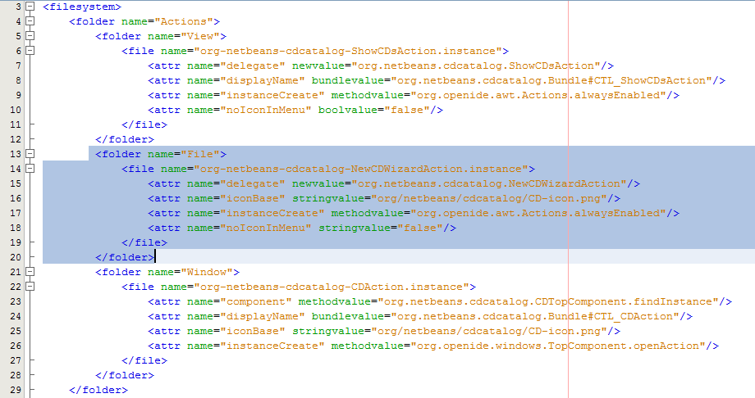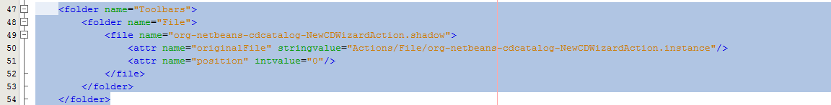

Blue marked spots are the made changes. The folder File represents some characteristics of our NewCDWizardAction that start our wizard. The Toolbars folder defines the GUI registration of our wizard.

Now modify the code of our ShowCDs Action as bellow, to make it display cds from our CD database singleton.

public final class ShowCdsAction implements ActionListener {

@Override
public void actionPerformed(ActionEvent e) {
PrintWriter out = IOProvider.getDefault().getIO("Cds", false).getOut();
// ArrayList<CD> cdDatabase = CDTopComponent.getDefault().getCdDatabase();
ArrayList<CD> cdDatabase = CdDatabase.getInstance().getCds();
for(CD cd : cdDatabase) {
out.println(cd);
}
}
}

Lets run our application again. Right click on MyNetbeansApplicationSuite and choose Run. Application at start up will look like this:

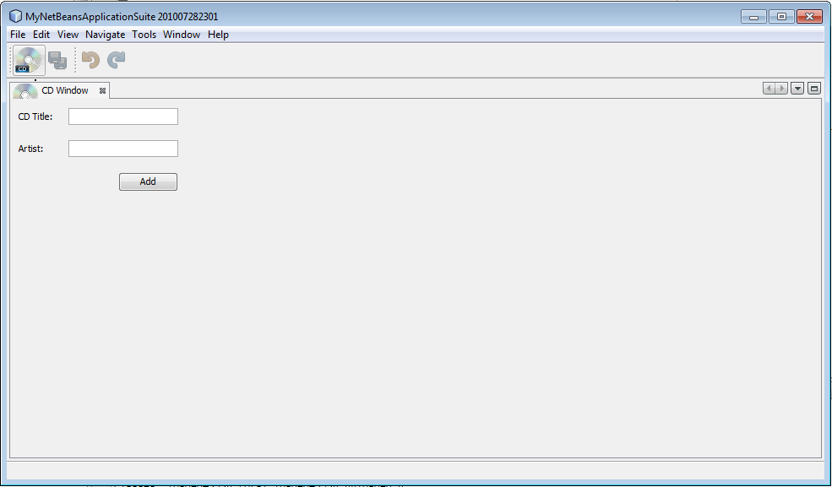

Click on the CD icon (that we defined in Layer.xml file – you can add any icon you want. Recommended size 16x16) and it will start our NewCD wizard:

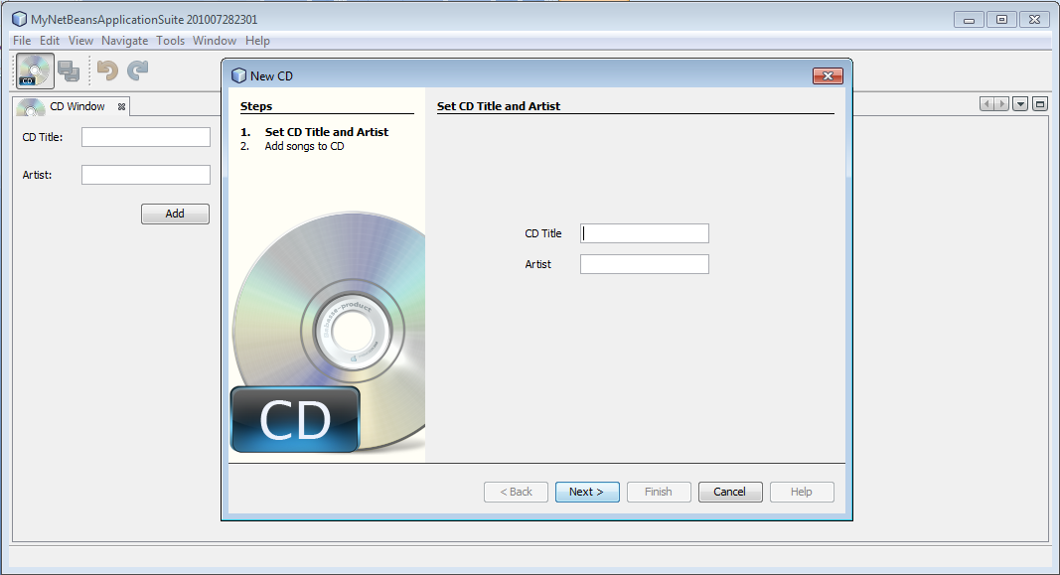
Add a couple of CDs again. (Note that wizards validation of filled values is not implemented. For further details look at http://platform.netbeans.org/tutorials/nbm-wizard.html the Validating User Data section)

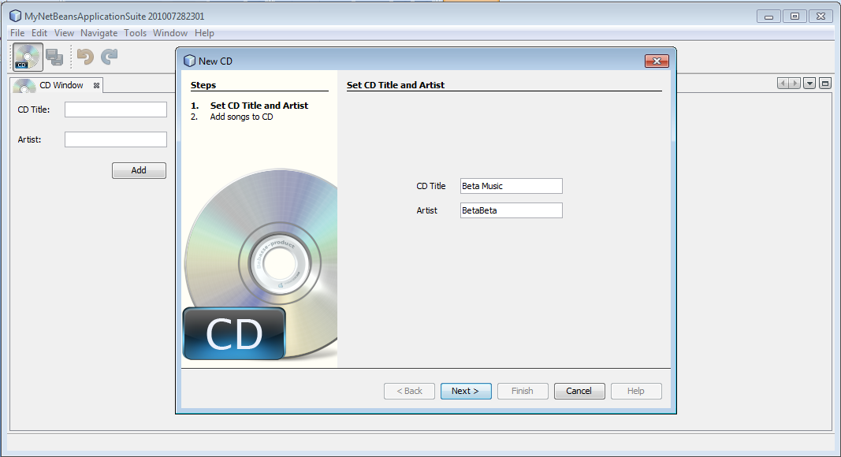

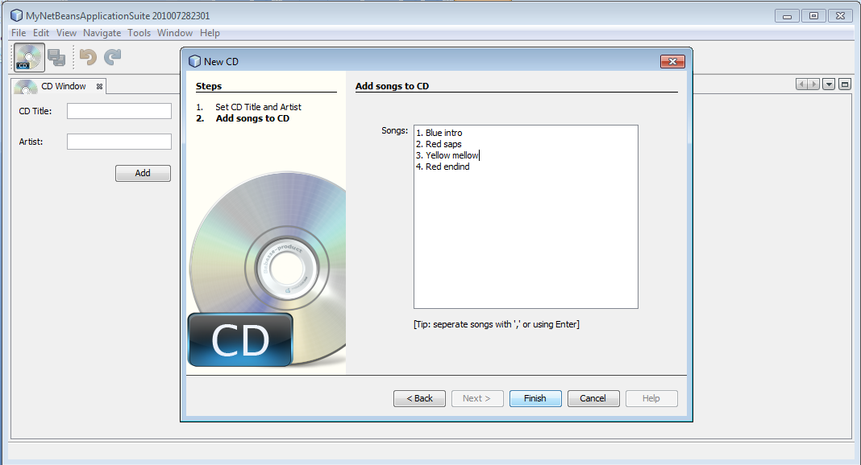

Now click Show CDs action to display entered cds.

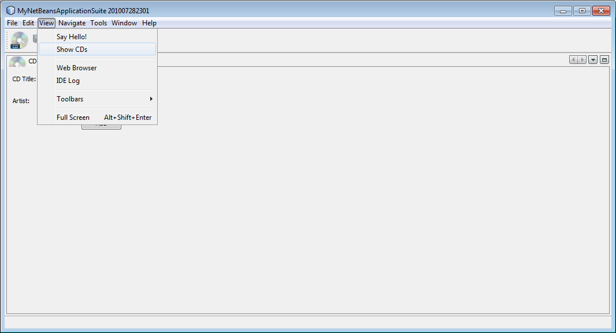

The result of ShowCDs Action is shown in Output window as below:

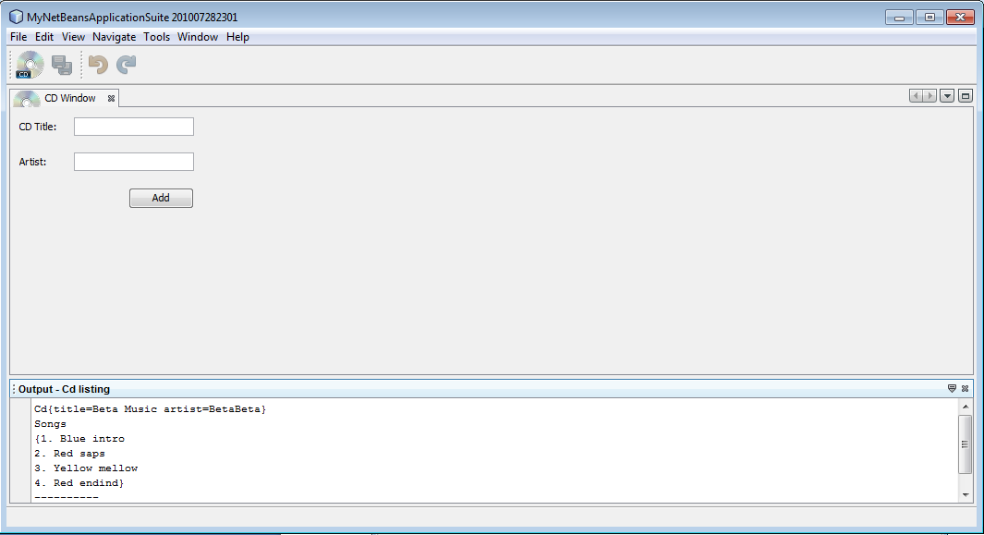

For more tutorials and further details look at
http://netbeans.org/features/platform/all-docs.html

